Photography Challenge 26-27
Nature's Palette: Capturing the Biodiversity of Our City
This year’s photography theme, Nature’s Palette: Capturing the Biodiversity of Our City, invites students to become nature explorers and document the native biodiversity that exists within their own urban environments. The project encourages participants to observe and photograph native plants, animals, insects, trees, birds, and aquatic life found in and around their city, while developing a deeper understanding of how geography, climate, urbanisation, culture, and ecosystems are interconnected. Through both photography and research, students are expected to tell meaningful stories about the species they capture, highlighting not only their ecological importance but also their relationship to local communities, traditions, and environmental challenges. The theme aims to help students recognise that biodiversity is not limited to forests and wildlife reserves, but exists all around them - on streets, in parks, near wetlands, and even in their neighbourhoods.
Reviewers should expect submissions that combine scientific inquiry, artistic expression, and authentic field observation. Each photograph must be original and include a visible authenticity element proving that the student personally captured the image. Alongside the photograph, students are required to provide researched captions that include species identification, location details, ecological or cultural significance, interesting facts supported by valid citations, and a personal reflection describing their experience or learning. Strong submissions will demonstrate careful observation, originality in composition, thoughtful storytelling, ecological understanding, and a genuine connection between the student and the natural world they are documenting.
The final submission includes:

- 7 original photos as per the rubric below
- A report as per the rubric below

Criteria | 4 | 3 | 2 | 1
Number of ORIGINAL photos | Students submit exactly 7 photographs that are clear and have a minimum resolution of 300 DPI. | Students submit only 6 photos  OR  Only 6 of the 7 photos meet the minimum resolution requirement of 300 DPI or are not clear/blurry/too dark | Students submit only 5 photos  OR  Only 5 of the 7 photos meet the minimum resolution requirement of 300 DPI or are not clear/blurry/too dark | Students submit less than 5 photos or more than 7 photos  OR  Less than 5 photos meet the minimum resolution requirement of 300 DPI or are not clear/blurry/too dark
Variety among Photographs | The photographs presented display a variety of photography techniques. The photographs differ from each other in at least 5 of the following 7 criteria:  1. Shot size and orientation (portrait, landscape, wide-angle or macrophotography)  2. Time of day/ Contrast and lighting (daylight, night time, evening, early morning)  3. Angle (eye level, low angle, high angle, over the shoulder angle, Dutch angle)  4. Subject of the photo (different places, different flora and fauna, landscapes, etc. in all 7 photos)  5. Shutter speed (photos that show motion exceptionally well as well as photos that capture still life)  6. Colour and tone (photographs with and without a filter to capture the right mood- using warm vs. cool tones, black & white, or selective colour for artistic effect)  7. Techniques (rule of thirds, leading lines, framing, depth of field) | The photographs differ from each other in only 4 of the following 7 criteria:  1. Shot size and orientation  2. Time of day / Contrast and lighting  3. Angle  4. Subject of the photo  5. Shutter speed  6. Colour and Tone  7. Techniques | The photographs differ from each other in only 3 of the 7 criteria  1. Shot size and orientation  2. Time of day / Contrast and lighting  3. Angle  4. Subject of the photo  5. Shutter speed  6. Colour and Tone  7. Techniques | The photos presented differ from each other in 2 or less of the 7 criteria or they all “feel the same” e.g., all are photos of buildings taken at low, wide angle in broad daylight, with a black and white filter or all photos are taken at eye level
Connection to the theme | All 7 photographs are clearly connected to the photography challenge described above. The audience should be able to see the connection immediately even without a narrative or a description. Every single photo selected by the students strongly aligns to the challenge presented to them. | At least 5 of the 7 photographs align to the challenge. | At least 4 of the 7 photographs align to the challenge | Less than 4 photographs align to the challenge.  OR  It is difficult for the viewer to understand the connections the students wish to make in 3 or more photos
Authenticity requirement | All 7 photos include proof of authenticity. This means the photographer must demonstrate that they personally captured the image. Downloaded or internet images will NOT be accepted. Acceptable proofs of authenticity are listed at the end of this rubric. | 6 of the 7 photos include proof of authenticity. | 5 of the 7 photos include proof of authenticity. | <5 of the 7 photos include proof of authenticity.
Written report  Two examples of this are given below for your reference | All 7 photos are accompanied with a written description that includes the following components (ALL components should be included in EVERY photo to get a score of 4):  - Title of photograph  - Species name  - Location  - Date and time  - Shot on  - Description of the photo  - Two researched facts around emergence, tradition & culture, local influences, people and conservation, cultural significance or social & environmental impact  - Citations from a valid source, including links  - Personal reflection  - Filter/editing used | Only 6 photos are accompanied by the required written description – all components of the information must be included to get the full 3 points | Only 5 photos are accompanied by the required written description – all components of the information must be included to get the full 2 points  OR  All components are included in all photos but citations are not from a valid source or cannot be double checked by the reviewer as no links are included. | Less than 5 photos are accompanied by the required written description.  OR  More than 5 photos have the information included but it is not complete i.e. one or more of the written components are missing

Authenticity Examples
Any of the following or similar inclusions could be considered as valid proofs of authenticity
Proof | Example
Shadow in Frame | Shadow on ground while photographing a butterfly
Reflection | Reflection in a pond, puddle, or glass while photographing a bird
Hand or Arm in Frame | Hand pointing toward a flower or tree trunk
Silhouette | Standing near a tree at sunrise or sunset
Camera Strap or Equipment | Camera strap hanging in the
Behind-the-Scenes Shot | Wide shot showing the photographer in the field

PLEASE NOTE: We will be asking students to upload ORIGINAL photos to a Google Drive as part of their final submission. Without the original photos and the written reflections, the submission will be considered incomplete and may not be accepted for review.

Examples of Written Report

Example 1: Native Bird Photography
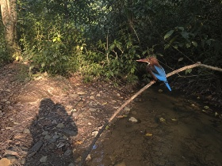
Title: "The Kingfisher's Watch"
Species: White-throated Kingfisher (Halcyon smyrnensis)
Location: Aarey Forest, Mumbai
Date and Time: May 5th 2026, 7:00 am
Shot on: iPhone 16
Description of the photo: A White-throated Kingfisher is perched on a thin branch above a small stream in Aarey Forest. The photographer's shadow is clearly visible on the ground below, stretching into the lower left corner of the image. The bird's vivid turquoise wings and chestnut chest are captured in sharp focus against a soft, blurred green background. Morning light creates a golden rim around the bird.
Interesting Facts:
- Ecosystem Role: The White-throated Kingfisher is a powerful hunter that eats insects, frogs, lizards, fish, and even small rodents. By feeding on many different animals, it helps keep their populations under control and maintains balance in the ecosystem.
Reference:
- Bombay Natural History Society (BNHS) - species descriptions and field guides
- BirdLife International - species factsheet on White-throated Kingfisher
- Cultural Belief: In many parts of India, especially near coastal and river communities, kingfishers are seen as signs of clean water and healthy surroundings. Fisherfolk often associate their presence with good fishing areas because the birds are usually found where there is plenty of prey.
Reference:
- Bombay Natural History Society (BNHS) - field observations and ecological notes on bird–habitat relationships
Personal Reflection by Photographer: I stood very still for almost ten minutes before this Kingfisher settled on this branch. My shadow tells you I was truly there, watching and waiting. Seeing it up close made me realise how much wild life still exists in our city.
Filter used: None

Example 2: Native Flower Photography
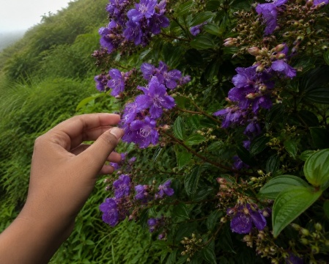
Title: "The Karvi Bloom"
Species: Karvi (Strobilanthes callosa)
Location: Sanjay Gandhi National Park, Mumbai
Date and Time: August 29th 2026, 9:10 am
Shot on: Acuvar 16MP Digital SLR Camera
Description of Photograph: A dense cluster of purple Karvi flowers fills the frame. The photographer's hand is gently extended toward the blooms, just touching the edge of a petal - not picking or disturbing the flower, but acknowledging their presence at this rare event. The background is a lush monsoon green.
Interesting Facts:
- Cultural / Local Significance: In parts of Maharashtra, the blooming of Karvi every 7–8 years is seen as a special natural event, and many people visit places like forests and hills to witness it. For local communities, it is a moment of pride and connection to their landscape.
Reference:
- Bombay Natural History Society (BNHS) - documentation of mass flowering events in the Western Ghats
- Maharashtra Forest Department - reports and public awareness around Karvi blooms
- Ecosystem and Traditional Knowledge: After Karvi blooms, the large number of flowers attracts bees and other pollinators, supporting honey production and local ecosystems. In some areas, people also recognise the bloom as part of traditional seasonal cycles in the Western Ghats.
Reference:
- Ashoka Trust for Research in Ecology and the Environment (ATREE) - studies on flowering cycles and pollinators
- Indian Institute of Science (IISc) - ecological research on mass flowering species
Personal Reflection by Photographer: Karvi blooms only once every seven years. I could not believe I was standing in front of it. My hand in the picture is my way of saying.’ I was here, I witnessed this miracle of nature.’
Filter Used: UV Protection filter

Example 3: Native Tree Photography
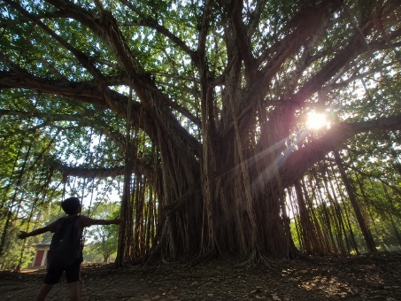
Title: "Roots of Mumbai"
Species: Banyan Tree (Ficus benghalensis)
Location: Shivaji Park, Dadar, Mumbai
Date and Time: August 15th 2026, 3:00 pm
Shot on: Google Pixel 10 Pro XL
Description of Photograph: A wide-angle shot of a massive, ancient Banyan tree. The photographer stands at the base, dwarfed by the enormous aerial roots and canopy. Their silhouette is visible at the left side of the frame, arms outstretched as if embracing the tree. Sunlight filters through the canopy, creating dramatic rays of light.
Interesting Facts:
- Cultural Significance in India: The Banyan tree is considered sacred in India and is often planted near temples. It is associated with long life and wisdom, and in some traditions, people worship it during festivals like Vat Savitri.
Reference:
- Ministry of Environment, Forest and Climate Change - cultural and ecological importance of native trees
- Forest Research Institute - documentation on traditional uses and significance of banyan
- Ecosystem Importance: A single Banyan tree can support hundreds of species of birds, insects, bats, and small animals by providing food (figs) and shelter. Because of this, it is often called a “keystone species” in its ecosystem.
Reference:
- Centre for Ecological Sciences, Indian Institute of Science - studies on fig trees and biodiversity
- Bombay Natural History Society - field observations on banyan ecosystems
Personal Reflection by Photographer: This Banyan tree is older than most buildings around it. Standing next to it made me feel how small I am and how important it is to protect trees like this one.
Filter Used: “Vivid”

Example 4: Coastal Life Photography
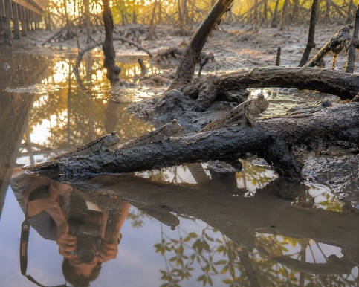
Title: "Mudskipper Morning"
Species: Mudskipper (Periophthalmus species)
Location: Versova Mangroves, Mumbai
Date and Location: November 1st 2026, 6:18 am
Description of Photograph: Three mudskippers are perched on exposed mangrove roots in shallow muddy water. The photographer is crouching at the edge of the mangrove boardwalk. Their camera, strap, and partial reflection are visible in the still water below. Early morning golden light reflects off the mud.
Interesting Facts:
- Unique Adaptation: Mudskippers can breathe air through their skin and the lining of their mouth, which allows them to survive on land for long periods. They must stay moist, which is why they live in muddy mangrove areas.
Reference:
- National Geographic Society - explains mudskipper amphibious breathing and behaviour
- Smithsonian National Museum of Natural History - research on mudskipper adaptations
- Mudskippers play an important role in mangrove ecosystems by feeding on insects and small organisms in the mud and by digging burrows, which helps aerate the soil and support other life.
Reference:
- Food and Agriculture Organization - mangrove ecosystem functions and species roles
- International Union for Conservation of Nature - mangrove biodiversity and species interactions
Personal Reflection by Photographer: Mudskippers are fish that have evolved to breathe air and walk on land. I never knew they existed in Mumbai until I visited Versova. My reflection in the water is proof I was right there at dawn.
Filter Used: None

